Erik Marrero

4/13/2020

Cs152

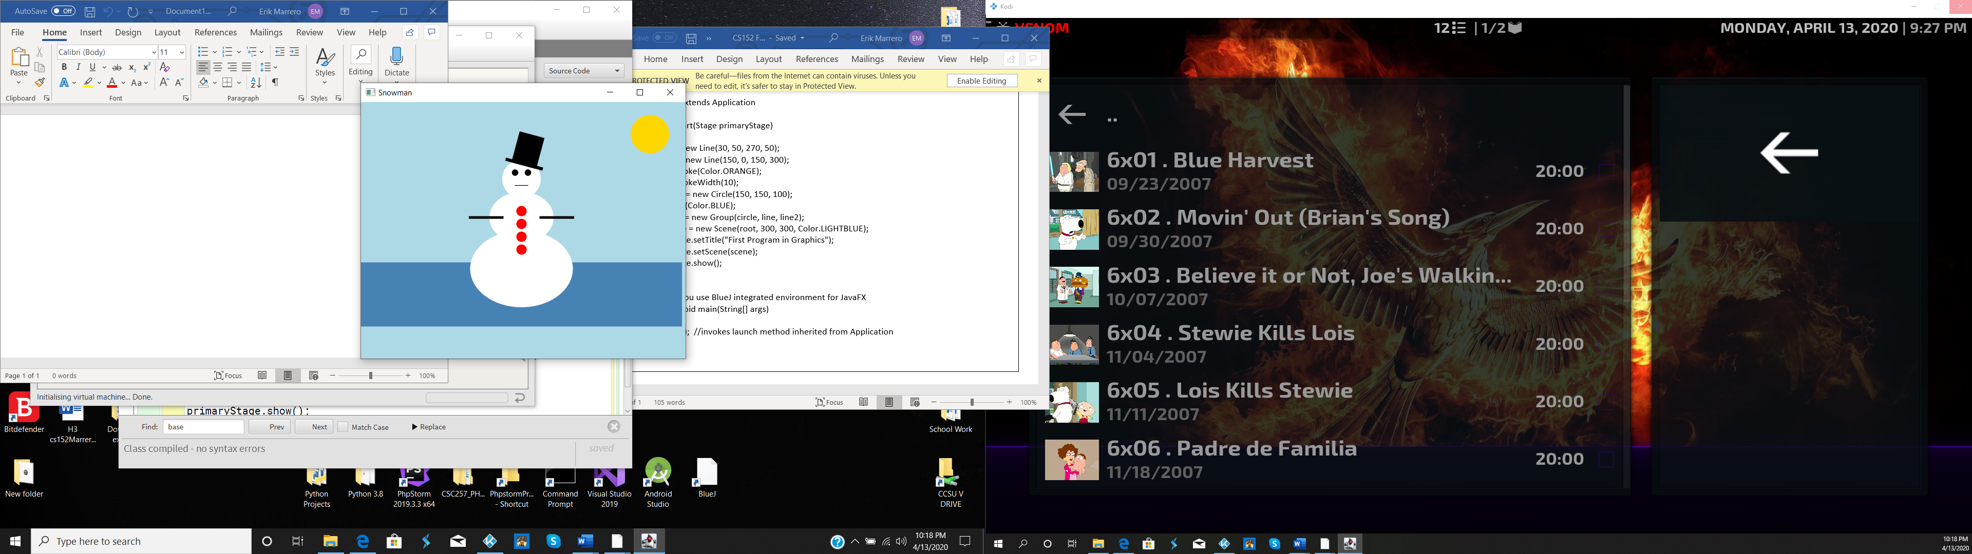

import javafx.application.Application;

import javafx.stage.Stage;

import javafx.scene.Group;

import javafx.scene.Scene;

import javafx.scene.paint.Color;

import javafx.scene.shape.\*;

public class Snowman extends Application

{

public void start(Stage primaryStage)

{

Circle head = new Circle(80, 70, 30);

head.setFill(Color.WHITE);

Ellipse middle = new Ellipse(80, 130, 50, 40);

middle.setFill(Color.WHITE);

Ellipse bottom = new Ellipse(80, 210, 80, 60);

bottom.setFill(Color.WHITE);

Circle rightEye = new Circle (70, 60, 5);

Circle leftEye = new Circle (90, 60, 5);

Line mouth = new Line (70, 80, 90, 80);

Circle topButton = new Circle (80, 120, 8);

topButton.setFill(Color.RED);

Circle secButton = new Circle(80, 140, 8);

secButton.setFill(Color.RED);

Circle thirdButton = new Circle(80, 160, 8);

thirdButton.setFill(Color.RED);

Circle fourthButton = new Circle(80, 180, 8);

fourthButton.setFill(Color.RED);

Line leftArm = new Line (110,130,160,130);

leftArm.setStrokeWidth(4);

Line rightArm = new Line (50, 130, 0, 130);

rightArm.setStrokeWidth(4);

Rectangle stovepipe = new Rectangle (60, 0, 40, 50);

Rectangle brim = new Rectangle(50, 45, 60, 5);

Group hat = new Group(stovepipe, brim);

hat.setTranslateX(10);

hat.setRotate(15);

Group snowman = new Group(head, middle,bottom, leftEye,

rightEye, mouth, topButton, secButton, thirdButton,

fourthButton,leftArm, rightArm, hat);

snowman.setTranslateX(180);

snowman.setTranslateY(50);

Circle sun = new Circle (50,50,30);

sun.setFill(Color.GOLD);

sun.setTranslateX(400);

Rectangle ground = new Rectangle(0,250, 500, 100);

ground.setFill(Color.STEELBLUE);

Group root = new Group(ground, sun, snowman);

Scene scene = new Scene(root, 600, 400, Color.LIGHTBLUE);

primaryStage.setTitle("Snowman");

primaryStage.setScene(scene);

primaryStage.show();

}

}